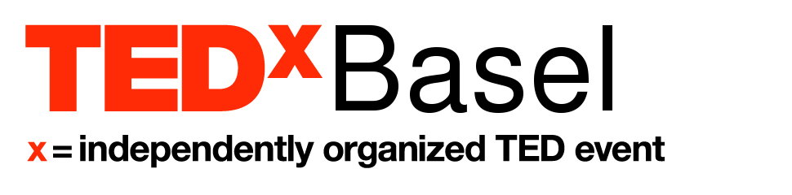

TEDxBasel took place for the first time on May 9th 2015 at the Naturhistorisches Museum Basel. A hugely informative and entertaining afternoon was had by 220 guests, who saw seven fascinating live talks, three TED videos, one wonderful fusion of dance and talk, and one musical performance demonstrating again Basel’s cutting edge in musical and artistic development. The event was moderated by Master of Ceremonies Gabriel Gee-Jay Jenny.

TED is an organisation devoted to ideas worth spreading. Our 9 speakers and performers, chosen from 65 applicants, led the narrative of our theme Past, Present, Future in examining history, current developments and the future in a variety of topics: technology, urban planning, social interaction and personal and local stories. All Basel residents; our speakers and performers were a wonderful representation of the inspiring people and unique ideas that can be found in our city.

Our guests were chosen from over 350 applicants, and represented a cross-section of the Basel community. Attendees were a mixture of Swiss natives and expatriates, ranging in age from 11 to over 70. They included scientists, artists, educators, economists, students, and professionals at every level, representing over 40 different fields.

TEDxBasel is a 100% volunteer-driven, non-profit organisation. It was produced by a small, diverse team, led by educator Jennifer Chough, a Canadian native. The event grew out of the success of TEDxGundeldingen which took place in November 2013. It was made possible by a large number of dedicated volunteers and the support of our many partners and friends, who believed in our idea.

TEDxBasel will take place again in 2016.

Photos

Please find photos of the event here: https://www.flickr.com/gp/132413268@N04/siZ1Z5
Videos of the talks and performances are currently being edited. They will be released soon.

Some quotes from TEDxBasel attendees about our event

“Wonderful location, great talks and all around cool people”

“We cannot think of anything that could have made it more enjoyable or informative. The mixture of past, present and future technologies and social interaction, coupled with the ballet and music performances, created another cultural experience.”

“The mingling of the audience during the break and apero added to the positive feeling”

“It was a great experience! I met so many interesting people, from the team, audience and speakers”

“Had a wonderful day at TEDxBasel. Feeling inspired and having tons of new ideas and plans”

“(Organisers) paid a lot of attention to the details. What a surprise to find a personalised notebook in the gift bag”

“Overall, a really great event”

“The speakers really did a great job getting the feel and pace of a TED talk”

Speakers/Performers
(Name - organisation - Talk title)
- Dominique Brodbeck - Professor of Biomedical Informatics at FHNW - Visualizing Human Data Trails
- Thomas Steinemann - Owner & CEO Philippe DuBois & Fils SA - Awaken your Princess
- Stefan Zanetti - Founder Qipp - Digital Urban Development
- Ina Nicosia-Schelker - Owner of Kid’s Camp International School, Manager at Foundgirl Records - Fail to Succeed
- Armando Braswell - Dancer and Choreographer at Ballett Basel - See More for Yourself
- Susan Clark - Educator - The Invention of Modern Color: Synthetic Dyes
- Silja Chouquet - CEO of Whydot & entrepreneur at Ubercurious - DE-scribe Medicines
- Armand Martin - entrepreneur, co-founder Infocentric & Power-Blox - Swarm Energy
- Amped & Wired - musical trio (Phoebe Lin, Ben-Gregor Smith, Nik von Frankenberg) - Cube Sessions

Gabriel Gee-Jay Jenny (Master of Ceremonies) - Radio & Television presenter

Partners
Producing Partners: i-net, Audiorent Clair AG
Main Partner: Christoph Merian Stiftung Basel
Supporting Partners: Baechtiger Immobilien, Copartner Revision AG, Connectiv AG, CCS von der Osten, Infibia, Launchlabs, Gabriel Hill Photographer, Unser Bier, Sugru

About TEDx, x = independently organized event
In the spirit of ideas worth spreading, TEDx is a program of local, self-organized events that bring people together to share a TED-like experience. At a TEDx event, TED Talks video and live speakers combine to spark deep discussion and connection. These local, self-organized events are branded TEDx, where x = independently organized TED event. The TED Conference provides general guidance for the TEDx program, but individual TEDx events are self-organized. (Subject to certain rules and regulations.)

About TED
TED is a nonprofit organization devoted to Ideas Worth Spreading, usually in the form of short, powerful talks (18 minutes or fewer) delivered by today's leading thinkers and doers. Many of these talks are given at TED's annual conference in Vancouver, British Columbia, and made available, free, on TED.com. TED speakers have included Bill Gates, Jane Goodall, Elizabeth Gilbert, Sir Richard Branson, Nandan Nilekani, Philippe Starck, Ngozi Okonjo-Iweala, Sal Khan and Daniel Kahneman.

TED's open and free initiatives for spreading ideas include TED.com, where new TED Talk videos are posted daily; the Open Translation Project, which provides subtitles and interactive transcripts as well as translations from thousands of volunteers worldwide; the educational initiative TED-Ed; the annual million-dollar TED Prize, which funds exceptional individuals with a "wish," or idea, to create change in the world; TEDx, which provides licenses to thousands of individuals and groups who host local, self-organized TED-style events around the world; and the TED Fellows program, which selects innovators from around the globe to amplify the impact of their remarkable projects and activities.

Follow TED on Twitter at http://twitter.com/TEDTalks, on Facebook at http://www.facebook.com/TED or Instagram at https://instagram.com/ted.

For further information, please contact

Jennifer Chough
Main Organizer
078 676 8408
jennifer@tedxbasel.ch

Tessa Rawson
Communications Director
tessa@tedxbasel.ch

